

**UGANDA LOWER SECONDARY CERTIFICATE OF EDUCATION**

**END OF TERM 2 ASSESSMENT 2024**

PHYSICS P535/1

PAPER 1 (THEORY)

SENIOR ONE

2 Hours

**INSTRUCTIONS TO CANDIDATES**

* This paper consists of **three** (**3**) **compulsory** scenario-based items carrying equal marks.
* You are required to attempt **ALL** questions from this paper.
* Silent non-programmable scientific calculators may be used.
* You may lose marks if you do not show your working or if you do not use appropriate S.I units.
* Poor handwriting and untidy work shall lead to loss of marks.
* At the end of the examination, fasten all your work securely together. Where necessary, assume;

|  |  |
| --- | --- |
| • Acceleration due to gravity, g | = 10 ms-2 |
| • Density of water | = 1000 kgm-3 |

SECTION A

## Item 1

Due to poor laboratory practices, senior one students of Ndeeba Senior Secondary School– Kayunga often get injuries in the laboratory. Following this, a debate motion stating that, “**Physics should be abolished”** has been moved by people who do not know about Physics.

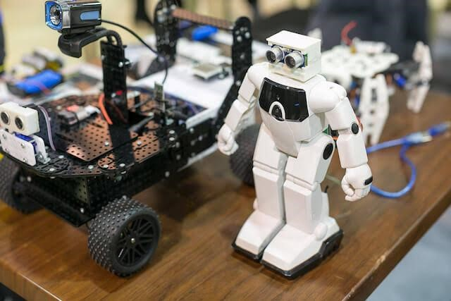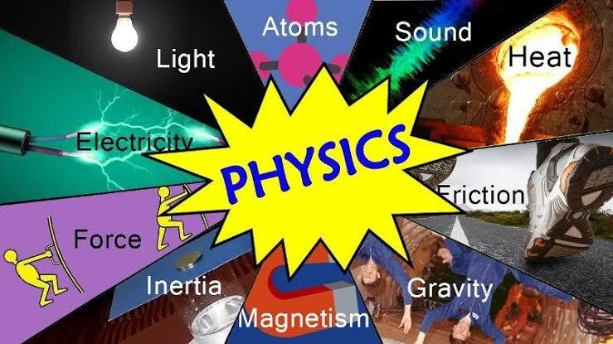

## Tasks

1. You have been chosen to enlighten the learners about the importance of Physics and its contribution in the society. Write and present a speech on how you would defend the learning

Of Physics. (**10 scores**)

1. It is common practice for learners to fear visiting laboratories for practical learning. As a Physics student,



* 1. Identify any **five** of such fears among learners. (05 scores)
  2. Suggest any **three** (3) ways of managing such fears. (03 scores)
  3. Suggest the safety precautions and measures to be followed while in the laboratory.(**02 scores**)

## Item 2

After completing Lower Secondary Education, Ibrahim and Rennet agreed to join a technical college after which they will setup a joint workshop. On completion of their technical course, they are offered space-measuring **6.5 m** by **10 m**.

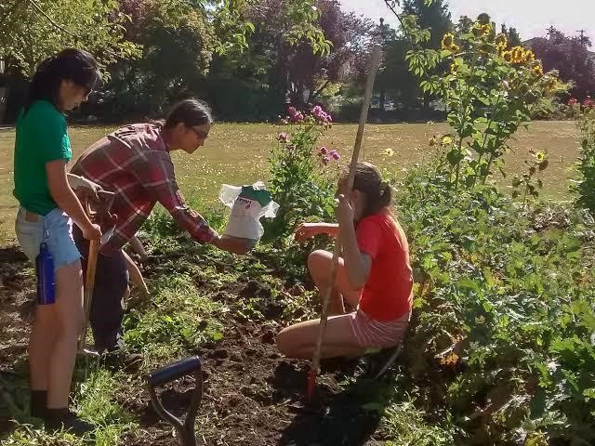

## Tasks

Using the knowledge of Physics and Laboratory,

1. Suggest activities for the workshop that are relevant to your community. (05scores)
2. How best can you plan for the given space? (10 scores)
3. Suggest measures to ensure safety in the workshop. (**05 scores**)

## Item 3

Roshan and his father have been living and renting in the city center. His father recently obtained a bank loan worth **UGX 18,000,000** from Centenary Bank. He later bought a piece of plotted land measuring **120ft** by **80ft** in your ancestral village to construct a self-contained residential house.

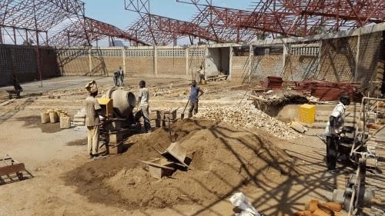

## Task

1. Design budget to enable purchase of materials needed to finish the construction. (08 scores)
2. Design a good building plan (blueprint) to help in the construction. (08 scores)
3. What do you think are the benefits of good plan in your society? (04scores)
4. **\*\*\*\*THE END\*\*\*\***